Hiroshima Day Observance

69 YEARS LATER

Calling for the abolition of nuclear weapons to advance the vision of a nuclear free world

Wednesday, August 6
Unitarian Society of Hartford, 50 Bloomfield Avenue, Hartford
Pot Luck 5:30 PM

Remembrance with Music and Poetry at 7 PM

Candle Lighting Ceremony at 8 PM

The Fateful 25 Days  July 16 – August 9, 1945  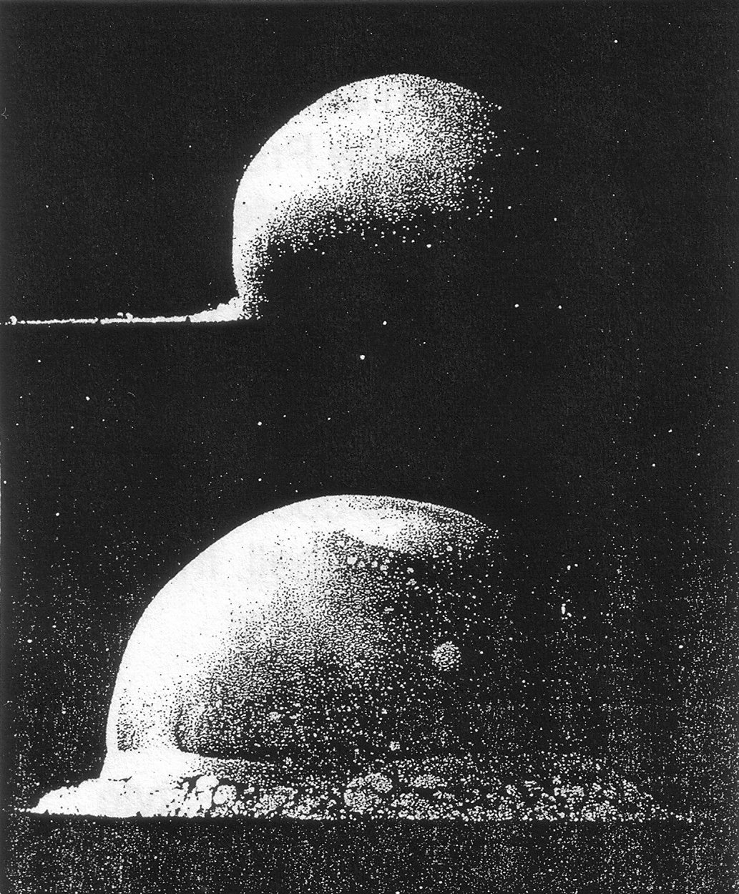  The initial 0.016 seconds  Alamogordo, NM July 16, 1945    A Child in Nagasaki  after August 9, 1945 | The Quest For Nuclear Abolition  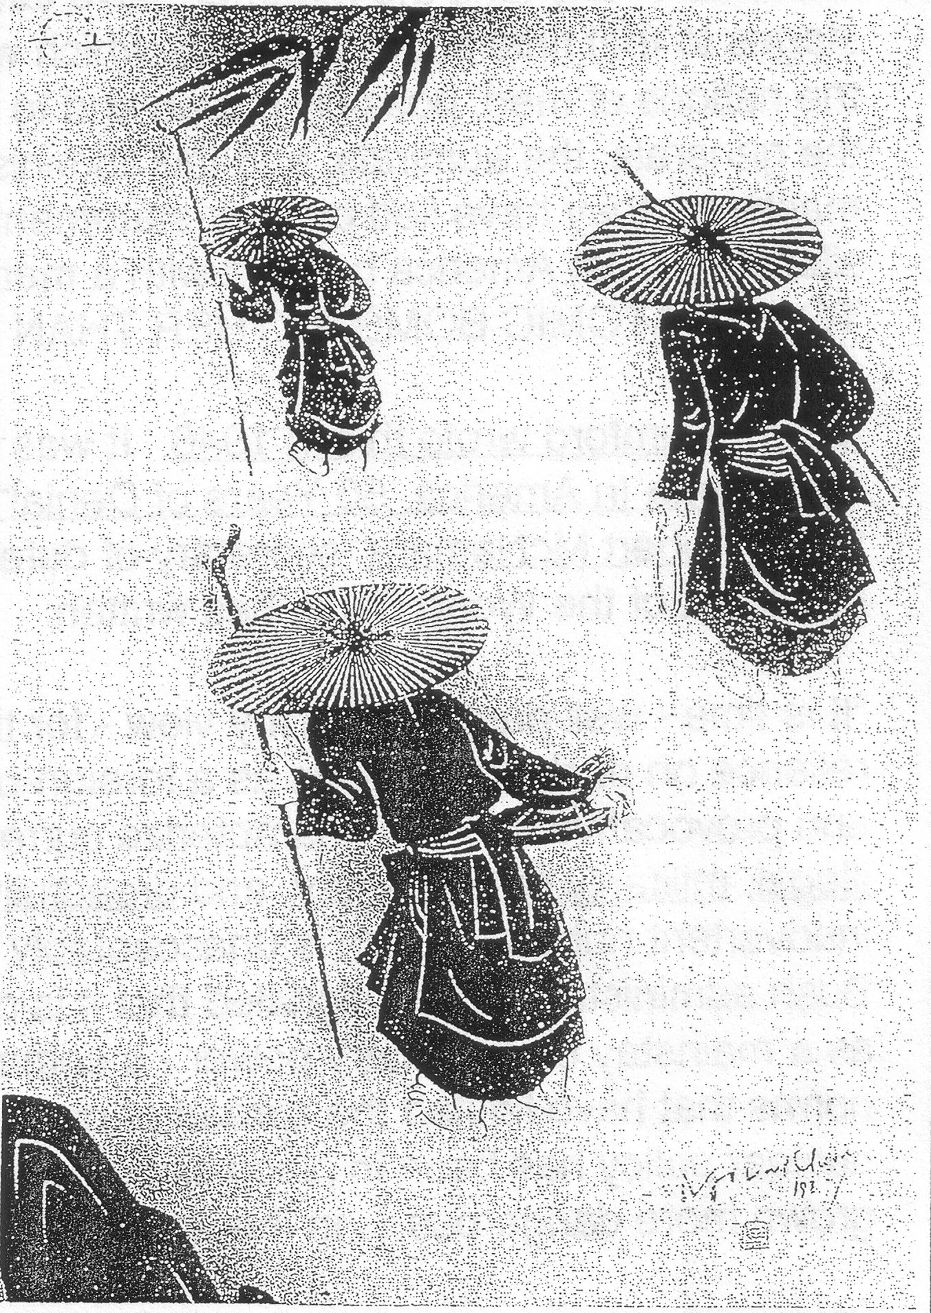  Power over life and death –  Don’t be proud of it  Whatever they fear from you, You’ll be threatened with.  SENECA

Sponsored by:
The American Friends Service Committee, Connecticut Coalition for Peace and Justice, Connecticut United For Peace, West Hartford Citizens for Peace and Justice

For more information on this event call Joseph Wasserman (860) 561-1897

www.hopeoutloud.org

WE IN AMERICA ARE LIVING AMONG MADMEN. Without a public mandate of any kind the madmen have taken it upon themselves to lead us by gradual stages to that final act of madness which will corrupt the face of the earth and blot out the nations of men, possibly put an end to all life on the planet itself. … the President, the generals, the admirals and the administrators have lied to us about their infernal machine: they have lied by their statements and even more they have lied by their silence. … let America be mad with a method, mad with a purpose. LET US SAY NO TO THE ATOMIC BOMB RATHER THAN SAY NO TO LIFE.

Lewis Mumford wrote this in 1946. It was quoted eleven years ago, in the book “Hiroshima in America. 50 Years of Denial,” by Robert J Lifton and Greg Mitchell.

In 2005, Robert McNamara, secretary of defense during the Vietnam War, and later president of the World Bank, wrote:

It is time - well past time, in my view—for the United States to cease its Cold War-style reliance on nuclear weapons as a foreign-policy tool. At the risk of appearing simplistic and provocative, I would characterize current U.S. nuclear weapons policy as immoral, illegal, militarily unnecessary, and dreadfully dangerous. The risk of an accidental or inadvertent nuclear launch is unacceptably high. Far from reducing these risks, the Bush administration has signaled that it is committed to keeping the U.S. nuclear arsenal as a mainstay of its military power - a commitment that is simultaneously eroding the international norms that have limited the spread of nuclear weapons and fissile materials for 50 years. Much of the current U.S. nuclear policy has been in place since before I was secretary of defense, and it has only grown more dangerous and diplomatically destructive in the intervening years.
…
We are at a critical moment in human history …. Neither the Bush administration, the congress, the American people, nor the people of other nations … examined the military utility of the weapons; the risk of inadvertent or accidental use; the moral and legal considerations relating to the use or threat of use of the weapons; or the impact of current policies on proliferation. Such debates are long overdue. If they are held, I believe they will conclude, as have I and an increasing number of senior military leaders, politicians, and civilian security experts: We must move promptly toward the elimination—or near elimination—of all nuclear weapons. For many, there is a strong temptation to cling to the strategies of the past 40 years. But to do so would be a serious mistake leading to unacceptable risks for all nations. ”

Meet with us on Hiroshima Day

Be an Abolitionist

“Apocalypse Soon”, Robert S. McNamara, Foreign Policy, May/June 2005, www.foreignpolicy.com and http://fparchive.ceip.org/story/cms.php?story_id=2829

